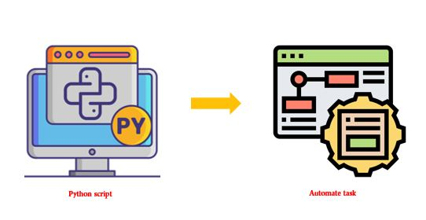**# Installation**

1. Python

https://www.python.org/downloads/

1. Vscode

https://code.visualstudio.com/

1. Important Extension for vs
2. Bright colors

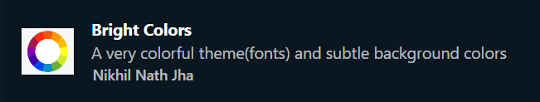

1. Color Highlight

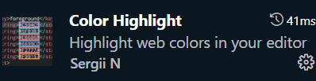

1. Prettier - Code formatter

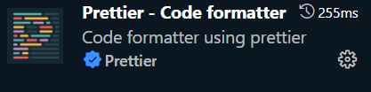

1. Python

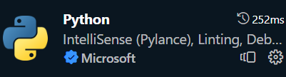

1. Python extension pack

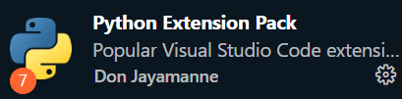

1. Python indent

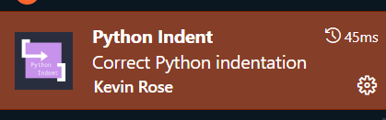

1. Vscode_pdf

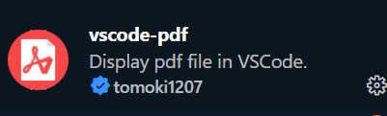

1. Code Runner

